Results Reporter
Out of 15 questions, you answered 15 correctly with a final grade of 100%
15 correct (100%)
0 incorrect (0%)
0 unanswered (0%)

Your Results:
The correct answer for each question is indicated by a .

1 CORRECT |  | What are transition words?
 |  | A) |  | special words help show the relationships between ideas within sentences within paragraphs
 |  | B) |  | special words that signal what is ahead
 |  | C) |  | special words that allow the author to carry you from one place in your reading "across" to another
 |  | D) |  | All of the above.
Feedback:
Transition words are special words help show the relationships between ideas within sentences within paragraphs. Good readers learn to utilize the author's transition words, which signal what is ahead. In Latin, the prefix trans means "across." Transition words allow the author to carry you from one place in your reading "across" to another.
2 CORRECT |  | These are examples of words that can be used to show____________________.
 |  | A) |  | classification or division (categories).
 |  | B) |  | cause-and-effect relationships.
 |  | C) |  | comparison.
 |  | D) |  | contrast.
Feedback:
3 CORRECT |  | These are examples of transition words that can be used to show____________________.
 |  | A) |  | classification or division (categories).
 |  | B) |  | cause-and-effect relationships.
 |  | C) |  | comparison.
 |  | D) |  | contrast.
Feedback:
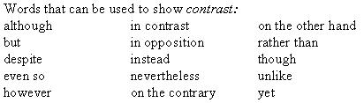
4 CORRECT |  | These are examples of transition words that can be used to show____________________.
 |  | A) |  | classification or division (categories).
 |  | B) |  | cause-and-effect relationships.
 |  | C) |  | comparison.
 |  | D) |  | contrast.
Feedback:
5 CORRECT |  | These are examples of transition words that can be used to show____________________.
 |  | A) |  | classification or division (categories).
 |  | B) |  | cause-and-effect relationships.
 |  | C) |  | comparison.
 |  | D) |  | contrast.
Feedback:
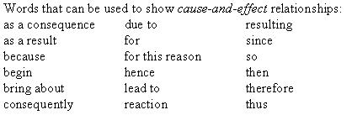
6 CORRECT |  | These are examples of transition words that can be used to show____________________.
 |  | A) |  | steps in a process.
 |  | B) |  | examples.
 |  | C) |  | definitions.
 |  | D) |  | chronological order.
Feedback:
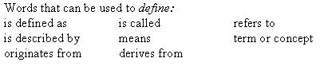
7 CORRECT |  | These are examples of transition words that can be used to show____________________.
 |  | A) |  | steps in a process.
 |  | B) |  | examples.
 |  | C) |  | definitions.
 |  | D) |  | chronological order.
Feedback:
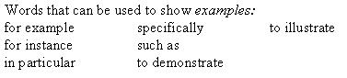
8 CORRECT |  | These are examples of transition words that can be used to show____________________.
 |  | A) |  | steps in a process.
 |  | B) |  | examples.
 |  | C) |  | definitions.
 |  | D) |  | chronological order.
Feedback:
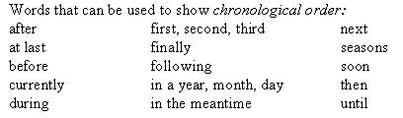
9 CORRECT |  | These are examples of transition words that can be used to show
 |  | A) |  | steps in a process.
 |  | B) |  | examples.
 |  | C) |  | definitions.
 |  | D) |  | chronological order.
Feedback:

10 CORRECT |  | The pattern of organization called _________________ is the process of organizing information into categories.
 |  | A) |  | classification and division
 |  | B) |  | cause and effect
 |  | C) |  | comparison and contrast
 |  | D) |  | steps in a process
Feedback:
Writers organize their supporting sentences and ideas in ways called patterns of organization. The most common kinds of patterns of organization are: classification and division, cause and effect, comparison and contrast, steps in a process, examples, definition and chronological order. Classification is the process of organizing information into categories. A category is created by noticing and defining group characteristics. The categories we create make it easier to analyze, discuss, and draw conclusions.
11 CORRECT |  | When using the pattern of organization called _________________, the author explains or describes something in a step-by-step manner.
 |  | A) |  | classification and division
 |  | B) |  | cause and effect
 |  | C) |  | comparison and contrast
 |  | D) |  | steps in a process
Feedback:
Writers organize their supporting sentences and ideas in ways called patterns of organization. The most common kinds of patterns of organization are: classification and division, cause and effect, comparison and contrast, steps in a process, examples, definition and chronological order. In the steps in a process pattern, something is explained or described in a step-by-step manner. The sequences are clearly identified by specific transition words.
12 CORRECT |  | A paragraph of ______________ will define, clarify, or explain a key term.
 |  | A) |  | examples
 |  | B) |  | definition
 |  | C) |  | chronological order
 |  | D) |  | listing pattern
Feedback: A paragraph of definition will define, clarify, or explain a key term. Definitions can be developed by providing dictionary meanings or personal meanings. They can also be developed by means of examples or by comparing and contrasting the key word to other words.
13 CORRECT |  | This pattern of organization involves arranging events in time in the order that they actually happened:
 |  | A) |  | examples
 |  | B) |  | definition
 |  | C) |  | chronological order
 |  | D) |  | listing pattern
Feedback: The word chronological comes from the Greek root chron, which means "time." This pattern of organization involves arranging events in time in the order that they actually happened.
14 CORRECT |  | When an author simply lists information without regard to order, the pattern of organization is referred to as____________________.
 |  | A) |  | examples.
 |  | B) |  | definition.
 |  | C) |  | chronological order.
 |  | D) |  | listing pattern.
Feedback: When an author simply lists information without regard to order, the pattern of organization is referred to as simple listing or enumeration. Sometimes authors use numbers (1,2,3), letters (a, b, c) or asterisks (*) to show the individual items on the list.
15 CORRECT |  | A paragraph of ___________ usually gives a general statement of the main idea and then presents one or more concrete examples to provide support for his idea.
 |  | A) |  | examples
 |  | B) |  | definition
 |  | C) |  | chronological order
 |  | D) |  | listing pattern
Feedback: A paragraph of examples usually gives a general statement of the main idea and then presents one or more concrete examples to provide support for this idea. Many writers place the most important or convincing example either first, as an attention-getter, or last, as a dramatic climax. While the terms example and illustration are used interchangeably, an illustration is usually longer, and there may only be one in the paragraph.

